CO2 ASSESSMENT TOOL – 1
Scenario-Based Requirement Analysis
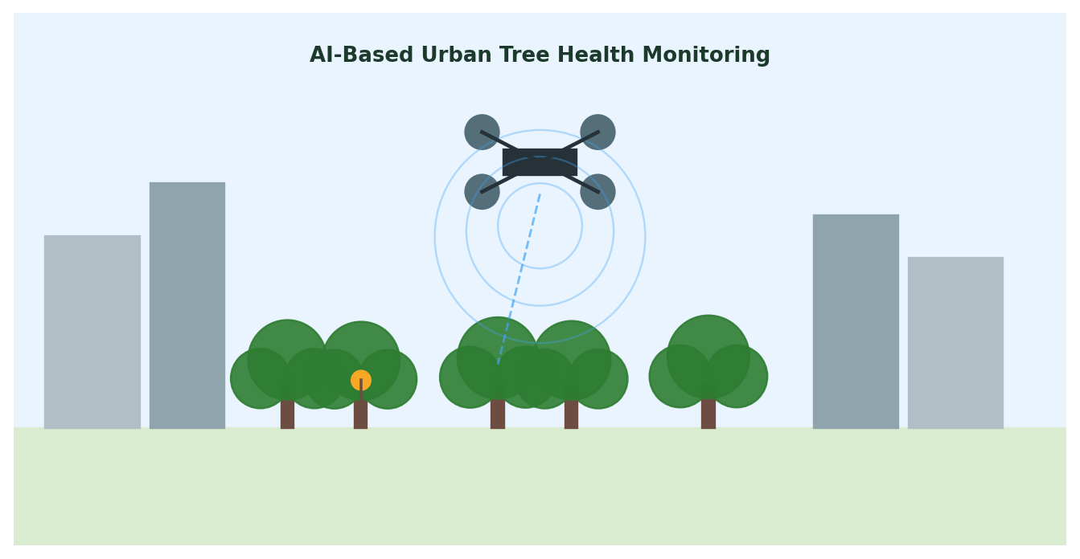

Smart AI-Based Urban Tree Health Monitoring and
Green Space Management System

Student Name | Divya Prashanth S
Register Number | 192521361
Course Code | CSA1017- Software Engineering
CO Assessed | CO2 AT1
Assessment | Assessment Tool 1 - Scenario-Based Requirement Analysis

PROBLEM STATEMENT

24. Smart AI-Based Urban Tree Health Monitoring and Green Space Management System
- Industry Context
- Urban forests and green spaces play an important role in improving air quality, biodiversity, and climate resilience.
- Municipal authorities require intelligent systems to monitor tree health and
- manage urban vegetation efficiently.
- AI, drones, satellite imagery, GIS, and IoT sensors enable
- continuous environmental monitoring and predictive maintenance.
- Problem Statement.
- Urban trees are affected by diseases, pest infestations, pollution, and climate change, but manual inspections are infrequent and resource-intensive.
- This results in delayed interventions and declining
- green cover.
- An AI-powered urban tree monitoring platform should analyze drone imagery, monitor environmental conditions .
- detect tree diseases, assess growth patterns, and recommend maintenance activities.
- The system should support sustainable urban forestry management and
- environmental conservation.

Rubrics for Calculation:

Criteria | Excellent (4) | Good (3) | Satisfactory (2) | Needs Improvement (1)
Scenario Understanding & Problem Analysis | Thorough understanding of scenario, stakeholders, objectives, business context. | Good understanding, minor omissions. | Basic understanding, limited analysis. | Poor understanding; major aspects missing.
Functional & Non-Functional Requirement Identification | Comprehensive, accurate, well-classified requirements. | Most requirements, minor classification errors. | Only basic requirements; several omissions. | Incomplete/inaccurate/poorly classified.
Actor Identification & Use Case Modeling | All actors/use cases correct; UML-standard diagram. | Most actors/use cases identified; minor diagram errors. | Limited actors/use cases; diagram partially correct. | Actors/use cases missing; diagram absent/inaccurate.
SRS Documentation | Well-structured, complete, professionally organized. | Organized, minor missing sections/formatting issues. | Only essential sections, limited detail. | Incomplete, poorly organized, lacks components.
Assumptions, Constraints & Requirement Validation | Realistic assumptions/constraints; thorough validation with justification. | Most assumptions/constraints; adequate validation. | Limited assumptions/constraints; superficial validation. | Missing or incorrect.
Criteria | Mark
Scenario Understanding and Problem Analysis | /5
Functional and Non-Functional Requirement Identification | /5
Actor Identification and Use Case Modeling | /5
Software Requirement Specification (SRS) Documentation | /5
Assumptions, Constraints, and Requirement Validation | /5
TOTAL | /25

1. Introduction
Urban forests are a critical part of city infrastructure, contributing to air purification, temperature regulation, biodiversity support, and the overall well-being of residents. As cities expand, municipal forestry departments face growing difficulty in tracking the health of thousands of trees using manual, periodic inspections. This document presents a Scenario-Based Requirement Analysis and Software Requirement Specification (SRS) for a Smart AI-Based Urban Tree Health Monitoring and Green Space Management System that uses drone imagery, satellite data, IoT sensors, GIS mapping, and AI models to continuously monitor tree health, detect disease, and recommend maintenance action.

1.1 Purpose
The purpose of this document is to analyze the given scenario, identify stakeholders and system requirements, model the actors and use cases, and produce a structured SRS that can guide the design and development of the proposed platform.

1.2 Business Domain
The system operates in the urban environmental management / smart city domain, specifically municipal urban forestry and green space administration, supported by AI, remote sensing, and GIS technologies.

2. Problem Description
Urban trees are continually exposed to diseases, pest infestations, air and soil pollution, and the effects of climate change. Municipal authorities currently rely on manual, infrequent field inspections that are labour-intensive, slow, and unable to scale across large urban tree populations. As a result, early symptoms of disease or stress often go unnoticed until the damage is severe, leading to tree loss, declining green cover, and reduced environmental quality. There is a clear need for an automated, data-driven platform that can continuously observe tree health using drone/satellite imagery and IoT sensors, apply AI models to detect disease and assess growth, and generate timely, prioritized maintenance recommendations.

3. Scope of the System
The proposed system will:
- Continuously monitor the health of urban trees using aerial imagery and ground-based IoT sensors.
- Apply AI/ML models to detect diseases, pest infestation, and abnormal growth patterns from imagery.
- Track environmental stress factors such as pollution levels, soil moisture, and temperature.
- Maintain a GIS-based digital map of all monitored trees and green spaces.
- Generate maintenance and intervention recommendations for forestry staff.
- Provide dashboards and reports to support data-driven urban planning decisions.
The system does not replace on-ground expert judgement for complex interventions but supports and prioritizes it with data-driven insight. Physical tree treatment, planting, and removal operations remain manual field activities outside the system's scope.

4. Stakeholders
Stakeholder | Role / Interest
Municipal Urban Forestry Department | Owns and operates the system; uses it to plan maintenance and budget resources.
Field Forestry Officers | Conduct ground verification and physical maintenance based on system alerts.
Drone/IoT Operators | Capture aerial imagery and maintain sensor network uptime.
AI/ML Analysts | Train, validate, and tune the disease-detection and analytics models.
City Planning & Environmental Agencies | Use aggregated data for sustainable urban planning and policy decisions.
Citizens/Residents | Report visible tree issues and view public green-space health information.
System Administrators | Manage users, access rights, and system configuration.

5. Functional Requirements
- FR1: The system shall capture and process drone and satellite imagery of urban tree canopies at scheduled intervals.
- FR2: The system shall use AI/ML models to detect signs of disease and pest infestation from captured imagery.
- FR3: The system shall analyze tree growth patterns over time using historical imagery comparisons.
- FR4: The system shall collect real-time environmental data (temperature, humidity, soil moisture, air quality) from IoT sensors.
- FR5: The system shall identify environmental stress factors affecting tree health, such as pollution or drought conditions.
- FR6: The system shall maintain a GIS-based map showing the location, species, and health status of each monitored tree.
- FR7: The system shall generate maintenance recommendations (e.g., pruning, treatment, irrigation, removal) ranked by urgency.
- FR8: The system shall allow field officers to log inspection findings and update tree records.
- FR9: The system shall allow citizens to submit reports/photos of visibly damaged or diseased trees.
- FR10: The system shall send automated alerts/notifications to relevant staff when a tree is flagged as high-risk.
- FR11: The system shall generate periodic reports and dashboards summarizing green-space health for city planners.
- FR12: The system shall allow administrators to manage user roles and access permissions.

6. Non-Functional Requirements
Category | Requirement
Performance | The system shall process a batch of drone imagery for a district within 30 minutes and support at least 10,000 monitored trees.
Security | The system shall encrypt sensor and imagery data in transit and at rest, and enforce role-based access control.
Reliability | The system shall maintain 99% uptime for data ingestion services and gracefully handle sensor/network failures.
Usability | Dashboards shall be usable by non-technical municipal staff with minimal training.
Scalability | The architecture shall support horizontal scaling as the number of sensors, drones, and monitored zones increases.
Maintainability | AI models and rule sets shall be updatable without requiring a full system redeployment.
Availability | Citizen-facing reporting features shall be available 24/7 with minimal scheduled downtime.
Interoperability | The system shall integrate with existing municipal GIS and asset-management platforms via standard APIs.

7. Actors and Use Cases

7.1 Actors
- Field Forestry Officer (primary) - performs ground inspection and maintenance actions.
- Urban Forestry Manager (primary) - reviews recommendations and allocates resources.
- Citizen (primary) - reports visible tree issues through a public interface.
- AI/ML Analyst (secondary) - maintains and improves detection models.
- System Administrator (secondary) - manages users, roles, and configuration.
- Drone/IoT Operator (secondary) - operates drones and maintains sensor hardware.

7.2 Use Case Descriptions (Sample)
Use Case | Actor(s) | Description
Monitor Tree Health Data | Field Forestry Officer / Urban Forestry Manager | View live and historical health status of trees in a given zone via dashboard.
Detect Tree Diseases (AI) | AI/ML Analyst (system-triggered) | AI model scans processed imagery and flags trees showing disease/pest symptoms.
Analyze Growth Patterns | AI/ML Analyst | Compare canopy size and density across time periods to assess growth trends.
Identify Environmental Stress Factors | System / Urban Forestry Manager | Correlate sensor readings with tree health decline to flag stress causes.
Generate Maintenance Recommendations | System / Urban Forestry Manager | System proposes prioritized maintenance actions based on AI findings.
Report Tree Condition | Citizen / Field Forestry Officer | Submit a report with photo/location for a visibly damaged tree.
Manage Users and Access Rights | System Administrator | Create/modify user accounts and assign role-based permissions.

7.3 Use Case Diagram
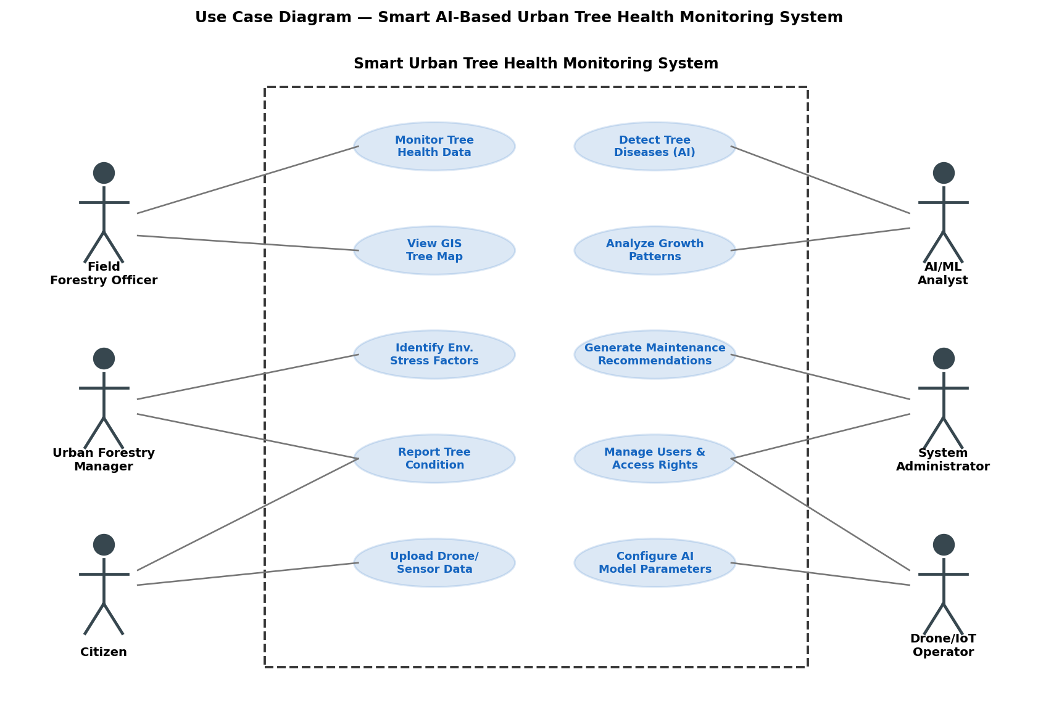

8. Software Requirement Specification (SRS)

8.1 System Architecture Overview
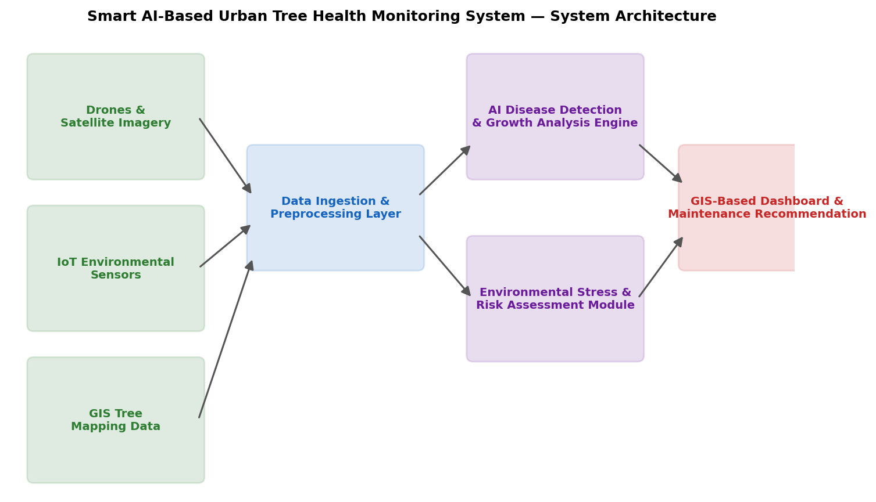

8.2 Data Requirements
- Drone/satellite imagery: geo-tagged images with timestamp, zone ID, and resolution metadata.
- IoT sensor data: temperature, humidity, soil moisture, air quality index, per sensor ID and timestamp.
- GIS data: tree ID, species, GPS coordinates, planting date, and administrative zone.
- Inspection and citizen report data: photos, notes, geolocation, and timestamp.
- AI model outputs: disease classification, confidence score, and growth trend metrics.

8.3 External Interface Requirements
- User Interfaces: Web dashboard for officers/managers/administrators; mobile app for citizen reporting and field data entry.
- Hardware Interfaces: Drone camera and IoT sensor data feeds via wireless/cellular connectivity.
- Software Interfaces: Integration with municipal GIS platforms and asset-management systems via REST APIs.
- Communication Interfaces: Secure HTTPS/API channels for data transfer between sensors, drones, and the central platform.

8.4 System Features
- AI-based disease and pest detection from imagery.
- Growth pattern analysis using time-series imagery comparison.
- Environmental stress correlation and alerting.
- GIS-based interactive tree map with health status overlays.
- Automated, prioritized maintenance recommendation engine.
- Citizen reporting portal with photo/location upload.
- Role-based dashboards and reporting for different stakeholder groups.

9. Assumptions and Constraints

9.1 Assumptions
- Drones and IoT sensors will be deployed and maintained across all target monitoring zones.
- Sufficient historical imagery is available or will be collected to train and validate AI models.
- Municipal staff will have basic digital literacy to use dashboards after minimal training.
- Network connectivity is available in most urban zones for near real-time data transfer.

9.2 Constraints
Type | Constraint
Technical | AI model accuracy depends on image quality, weather conditions, and sensor calibration.
Operational | Field verification is still required for high-risk cases flagged by the system.
Economic | Budget limits the number of drones, sensors, and coverage area in early deployment phases.
Legal | Data collection must comply with local privacy and drone-operation regulations.
Time | Model training and pilot-zone validation require a multi-month lead time before city-wide rollout.

10. Requirement Validation and Consistency Check

10.1 Completeness Check
All stakeholder groups identified in Section 4 have at least one corresponding functional requirement and use case: field officers and managers (monitoring and maintenance), citizens (reporting), analysts (AI model use cases), administrators (user management), and drone/IoT operators (data capture). Environmental, GIS, and reporting objectives from the problem statement are each mapped to at least one functional requirement.

10.2 Ambiguity, Redundancy, and Inconsistency Review
- Ambiguity: "Continuous monitoring" is refined with a concrete performance target (FR1, NFR-Performance) rather than left undefined.
- Redundancy: Disease detection and growth analysis were kept as separate requirements (FR2, FR3) since they use related but distinct AI models and outputs, avoiding overlap while remaining traceable.
- Inconsistency check: No functional requirement conflicts with a non-functional constraint; e.g., real-time alerting (FR10) is achievable within the stated 99% uptime and 30-minute processing targets.
- Missing requirement identified and added: an audit trail/logging requirement was not in the initial objectives list, so citizen report handling and admin actions are made traceable through system logs.

10.3 Suggested Improvements
- Add explicit data retention and privacy policy requirements for citizen-submitted photos and locations.
- Define measurable AI accuracy/precision thresholds for disease detection before production rollout.
- Introduce an offline/low-connectivity mode for field officers working in low-network zones.
- Add a feedback loop where field-verified outcomes are used to retrain and improve the AI models over time.

11. Conclusion
This scenario-based requirement analysis identifies a clear business need for automated urban tree health monitoring, defines the key stakeholders, functional and non-functional requirements, actors and use cases, and a structured SRS. The analysis has been validated for completeness and consistency, with targeted improvements suggested to strengthen the specification ahead of system design and development.

